一 首页新闻标题简短到两行

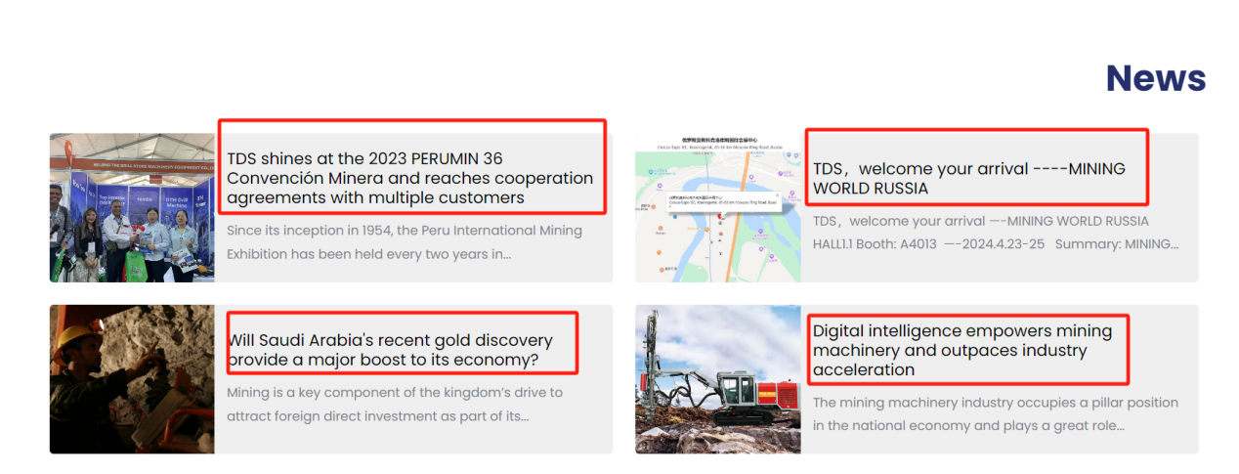

修改为：竖着看

TDS shines at the 2023 PERUMIN 36 Mining Convention

Gold mine was discovered in Saudi Arabia

TDS, welcome your arrival—MINING WORLD RUSSIA 2024

Digital intelligence empowers mining machinery

二需要放的参数 对应产品给对应参数 对应如下位置

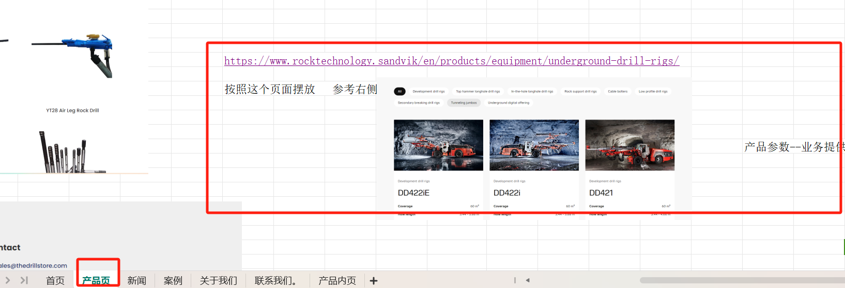

对应产品和参数：

TDS-560 Semi-Hydraulic DTH Drilling Rig

Hole Size: 95~130mm

TDS-600 Semi-Hydraulic DTH Drilling Rig

Hole Size: 90~165mm

[TDS-660 Semi-Hydraulic DTH Drilling Rig](http://daersite.huaxialifting.com/index.php/product/tds-660-semi-hydraulic-dth-drilling-rig-drilling-range-90350mm/" \o "TDS-660 Semi-Hydraulic DTH Drilling Rig  Drilling Range: 90~350mm" \t "http://daersite.huaxialifting.com/index.php/product-category/semi-hydraulic-drilling-rigs/_self)

[Hole Size: 90~350mm](http://daersite.huaxialifting.com/index.php/product/tds-660-semi-hydraulic-dth-drilling-rig-drilling-range-90350mm/" \o "TDS-660 Semi-Hydraulic DTH Drilling Rig  Drilling Range: 90~350mm" \t "http://daersite.huaxialifting.com/index.php/product-category/semi-hydraulic-drilling-rigs/_self)

TDS-TH500 Full Hydraulic Surface Top Hammer Drilling Rig

Hole Size: 60~90mm

TDS-TH700 Full Hydraulic Surface Top Hammer Drilling Rig

Hole Size: 76~115mm

TDS D10 Full Hydraulic DTH Drilling Rig

Hole Size:115~178mm

TDS D12 Full Hydraulic DTH Drilling Rig

Hole Size: 138~203mm

TDS D3 Full Hydraulic DTH Drilling Rig

Hole Size:90~130mm

TDS D6 Full Hydraulic DTH Drilling Rig

Hole Size:115~152mm

TDS D8 Full Hydraulic DTH Drilling Rig

Hole Size:115~178mm